Getting CIPPed through SportLomo
- Go to our Player Website page (Click Here) and scroll to the USA Rugby Membership section.
- Click on the Link to navigate you to USA Rugby SportLomo page.

- Search area under the Join USA Rugby, enter in:
  - Search by Type: Adult
  - Search by Region: Florida RU
  - Search by Club Name: Bay Area Pelican Rugby Football Club

- Our club should be listed at the bottom of the page. On our page, click on the Register link. An area should display at the bottom.
- Click on the Senior Player radio button and then click the register link at the bottom.
- Creating an Account in SportLomo or Activating your existing account
  - If you had a USA Rugby membership last year, click on the Log In page at the top. Enter your email and password that you had for USA Rugby. If you do not remember, you the forgot password link. You will be asked to active your account if you have not done it already.
  - If you are brand new to rugby and have never created an account, you will click on the sign-up page. Follow the instructions to create an account.
- After you successful create an account or successfully login into your account, you will enter 1 in the Num of Members on the row for Senior Player. Then Click on Continue
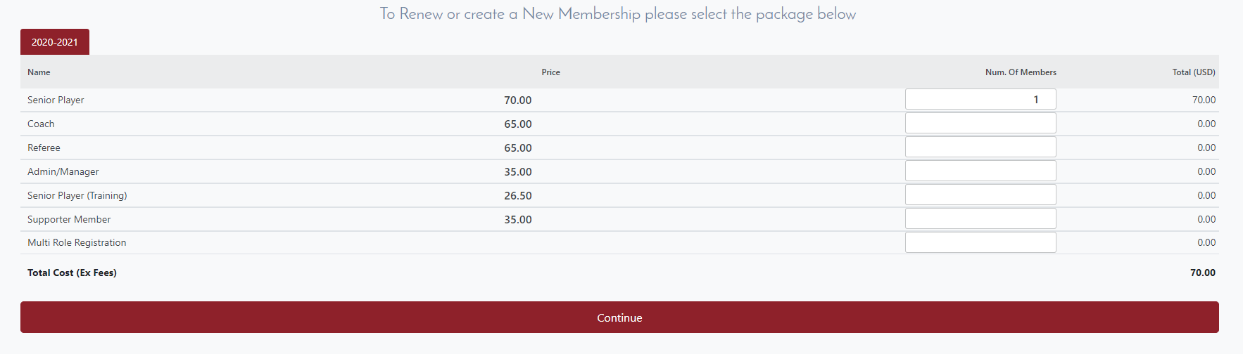
- Then you will enter in all your information including your Primary Medical Insurance. If you do not have any medical insurance just enter, 00000000 in both fields.
- Read through the Insurance Coverage, Rules Acknowledgement and Release of Liability. Afterwards, click on the check boxes.
- Read and scroll through the USAR Covid-19 Release. Then you will sign you name in the big text window.
- Type your name and click the Register link
- Enter in all your Credit Card information on the next page and click the Pay Now button at the bottom.
- After you pay, you will receive a receipt and then you are finished.

